Jess Adams
Performing Artist
Jess Adams grew up in Oreland, PA and began her dance training at the age of two. She graduated with a BFA in Dance from The University of the Arts in Philadelphia (2016). Jess began her career as a dancer and aerialist for Norwegian Cruise Lines, touring the Panama Canal, Costa Rica, Nicaragua, Guatemala, Mexico, Alaska and Canada. She performed 9 production shows a week for seven months. After her return to Philadelphia in 2017 she performed her own solo work at the Trocadero Theatre and performed for Kevan Sullivan & Dancers and Jim Bunting Dance Company at the Suzanne Roberts Theatre.

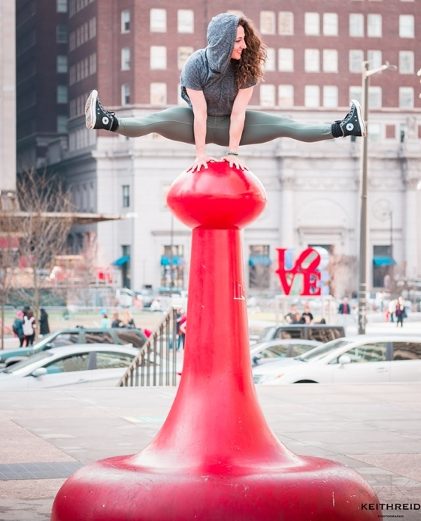
Today Jess is grateful to be a performing artist for three different companies-- JUNK, Almanac Dance Circus Theatre, and Project Moshen! She first performed for Brian Sanders’ JUNK in December 2016 as a volunteer Snowball dancer. She became a company dancer/aerialist/acrobat, making her debut at the Kimmel Center with the Philadelphia Orchestra (March 2019), performing a solo and duet in 2020's Philly Fringe show Out of the Darkness and currently working on another collaboration with the Philadelphia Orchestra for 2021. Since 2017, Jess has performed for Almanac at venues such as The New York Botanical Gardens, the PMA and the Philadelphia Convention Center. She performs and teaches for the community through YANJ, Playstreets and various Almanac workshops. In 2018, Jess joined Kelli Moshen’s contemporary/jazz dance company, performing at the Fillmore, Mutter Museum, 23rd Street Armory, Performance Garage, etc.

Jess danced in Matthew Schuler's (The Voice S5) official music video for We Rule the Night (2020). She enjoys working with other artists, including director Mark Janavel, photographer/multi-media artist John Singletary, make-up artist Seren Stylez, singer Martha Stuckey, the multifaceted Tyger B, Philadanco’s Victor Jr. Lewis, Matter Movement Group and more! Jess began teaching in 2010 and continues to teach dance and choreograph for numerous studios/companies. She values continuing her education and has additional dance/aerial/teacher training from Jacob’s Pillow, Secret Circus, Peridance Center, Broadway Dance Center, etc.

